Grade 7 Accelerated · Unit 4 · Lessons 2–3  Multiplying and Dividing in Scientific Notation  Question Bank 4.02 | Name______________________  Date______________________  Period____________________

Show your work. Circle your final answer.
For questions 1 through 6, multiply or divide. Write each answer in scientific notation.
1. 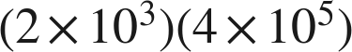

2. 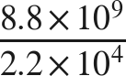

3. 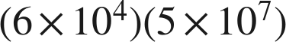

4. 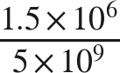

5. 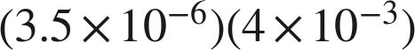

6. 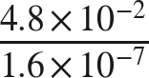

Real quantities.
7. Three meteorites have masses 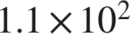, 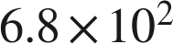 and 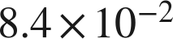 grams.
a. How many times as heavy as the lightest one is the heaviest one? Round to the nearest whole number.

b. How many times as heavy as the lightest one is the gram one? Round to the nearest whole number.

8. A data center processes about 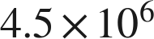 records per hour.
a. How many records does it process in  hours?

b. A second center processed  records in 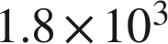 hours. How many records per hour is that?

Working backwards.
9. Find the missing number in each equation.
a.

b. 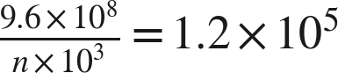

c. 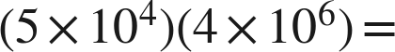 ______

Reading someone else's work.
10. Tyree multiplies 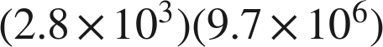 and writes . Is his value correct? Is his answer written in scientific notation? Write the finished answer.

11. Which is the value of 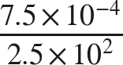 ?
○ A. 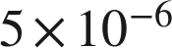
○ B. 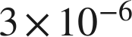
○ C. 
○ D. 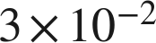

12. Select ALL of the expressions whose value is .
□ A. 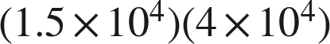
□ B. 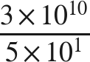
□ C. 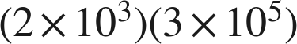
□ D. 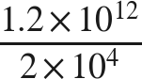
□ E. 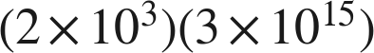
□ F. 